

The School of Technology
BSc (Hons) in Software Engineering
(Batch - 08)
Software Architecture and Design
4CS017
student name (id):
2502339

Module Leader: Ms. Suranji Nadeeshani
Submission Date: 15/01/2025

The third prototype has been developed with an emphasis on improving performance and user experience through browser caching using the local storage Java Script API. By leveraging this technology, the application aims to reduce unnecessary network requests, thereby improving response times and ensuring data availability even in offline situations. This architectural decision brings significant benefits, including performance optimization, reduced server load, and coast efficiency. It also comes with challenges such as data expiration, storage limitations, security issues, and browser compatibility.

Cached weather information can quickly become outdated, and storing data in local storage. Which can be accessed via JavaScript, poses security issues. Browser compatibility issues can impact performance.Expanding storage capacity by using other storage options can help. Improving security through data encryption and ensuring cross-browser compatibility with rollback mechanisms will also strengthen the architecture.

Its strengths are that it improves performance by minimizing network requests, providing faster response times and a smoother user experience. It reduces server load, making the system more scalable under high traffic conditions. Also, offline availability ensures continuous access to weather data without an active internet connection, and cost effectiveness reduces the costs associated with data transfer.

As well as its strengths has its weaknesses. The potential for data expiration is a significant drawback, as cached, especially with rapidly changing weather. The storage limit of local storage can be limited for extensive data caching needs. Storing sensitive data in local storage raises security concerns.

The architecture offers significant strengths by reducing server load, enabling offline access, and reducing data transfer costs. Addressing potential vulnerabilities such as data storage limitations, security issues, data expirations are essential to ensure optimal performance.

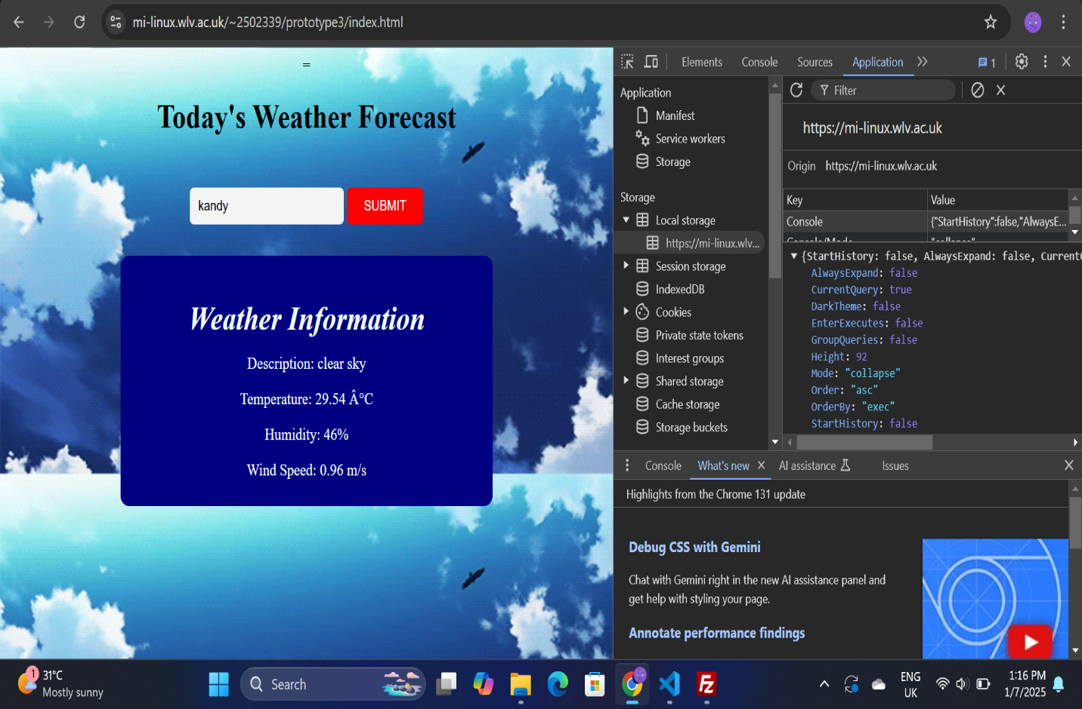

This is my Prototype 3 link,
https://mi-linux.wlv.ac.uk/~2502339/prototype3/index.html

